# INDEX

|  |  |  |
| --- | --- | --- |
| **Sr. No** | **TOPICS** | **PAGE NO.** |
| 1. | **INTRODUCTION**   * Existing System and Need for System * Scope of Work * Operating Environment - Hardware and Software Detail Description of Technology Used | 3 – 6 |
| 2. | **PROPOSED SYSTEM**   * Proposed System * Objectives of System * User Requirements | 6 – 9 |
| 3. | **ANALYSIS & DESIGN**  **(Web Based)**   * Module Hierarchy Diagram * Use Case Diagrams * Class Diagram * E-R Diagram * Activity Diagram * Sequence Diagram * Web Site Map Diagram (in case of Web Site) * User Interface Design (Screens etc.) * Database Table Structure | 9 -27 |

## Introduction of Bike RentalSystem

This system is named as Bike on Rent Management System. This system is designed to help the customers to take bikes or two-wheelers for rent. When we go on any trip outside the town or country, we want to be free of time so instead of going through metros and taxis, we prefer to have our own vehicle for rent.

Using this system vehicle owners can register as sellers and customers who want to take bikes on rent can register themselves as renters and can take any bike on rent. Address of the both are required as the customer can only take bike by going to the address provided and the vehicle owners can know the address that a customer is verified or not. The customer also has to upload some proofs to take the bike on rent.

Proofs like license, pan card, and identity card are compulsory so that no one could run taking the bike. Any customer whose proofs are not uploaded and are not valid will not be allowed to take any bike on rent. This has one admin account that verifies the registering user and two types of user account. One for bike sellers and one for customers who take the bike on rent.

A bike rental is a rented vehicle that can be used temporarily for a fee during a specified period. Getting a rental bike helps people get around despite the fact they do not have access to their own personal vehicle or don't own a vehicle at all. The individual who needs a bike must contact a rental bike company and contract out for a vehicle. This system increases customer retention and simplify vehicle and staff management.

This system has only one admin account and cannot have more than one admin account. Admin can verify and register the user who is registering. If the admin does not verify, the user cannot register. All other features are explained further in detail.

## Existing System and Need for System

* The Bike Rental System reduces time of taking manual Browsing of bikes for rents.
* This system will work efficiently and correctly as far as computer technology is concerned.
* This system will provide better security and transparency.
* Less User Friendly and Limited to Single System.
* This System Save the time of user for searching bikes all over the city.

## SCOPE OF SYSYTEM

This project was designed to investigate and related different functional, operational and technical requirement of a dedicated web application for online bike rental system.

The system equipped to answer customer’s inquiries about the availability and rental fee of various types of bikes for certain dates in the future.

The system process a bike pick up. Customer walks in and supplies either the confirmation number or name. The system should pull up all the reservation information about this customer. The customer is then asked to supply a driver’s license.

Bike rental system gives bike rental service for both foreign as well as local customers. This organization carries out its daily work by providing; their service to the customer using manually system

## Operating Environment - Hardware and Software Detail Description of Technology Used :

The Software Requirement deal with defining software resource requirements and prerequisites that needs to be installed on a computer to provide optimal functioning of an application.

Front End

* + User interface : HTML/CSS/JavaScript
  + Operating System : Microsoft Windows 7 or above
  + Web Browser : Chrome, Internet Explorer

Back End

* + Database : My SQL
  + Application Server : XAMPP server(v3.2.2) for Apache server(localhost)
  + PHP (v7.2.10) for server side scripting
  + Sublime3 (Source Code Editor)

**PROPOSED SYSTEM:**

* + - Our proposed system helps to maintain all records using database system, and the new feature that we are going to implement is maintain in this
    - application by offline.
    - As we are introducing the solution to existing problem it reduces time and it reduces lot of paper work and all the calculation and maintenance of the data is much easy compare to the manual system.

## Objectives of System:

* To produce a web-based system that allow customer to register and reserve a bike online and for the company to effectively manage their bike rental business.
* To ease customer’s task whenever they need to rent a bike.
* Availability of vehicle round the clock.
* Wide range of vehicles.
* Maintaining record of each booking history.
* Online payment option
* Login and account generation

## User Requirements:

* Registration and login
* Android phone, Desktop, Laptop
* User have to book bike

## Analysis And Design:

3.1 Module Hierarchy Diagram

Manage Order Confirmation

Manage Bikes

Login

Admin

User

Give Feedback

Book Bike

Login

Register

**Online Bike Rental Website**

## Use Case Diagram:

Register

Login

Add bike

**User**

View Bike

Check Bike Price

Book bike

View Booking List

**Admin**

Confirm Booking

Give Feedback

## Class Diagram:

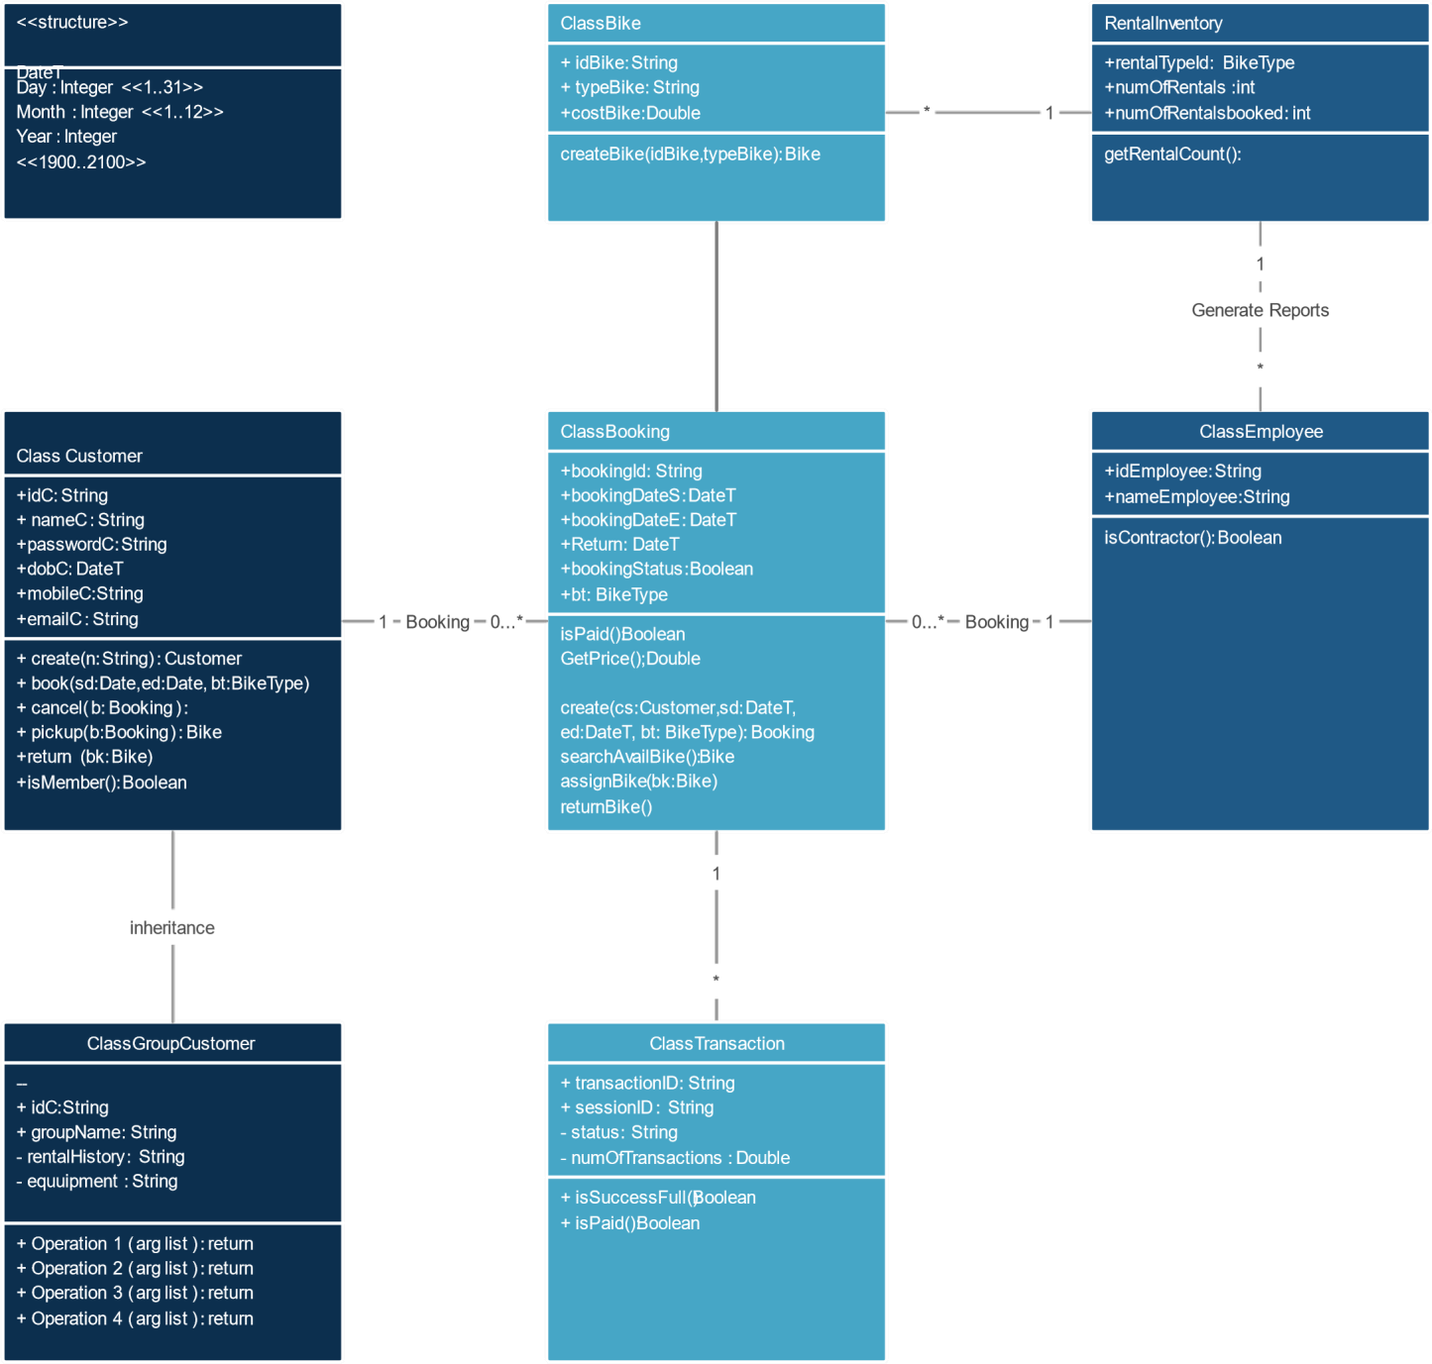

**Entity – Relationship Diagram**

An Entity Relationship model, also called as Entity – Relationship (ER) Diagram, is a graphical representation of entities and their relationship to each other, typically used in computing in regard to the organization of data within databases or information systems.

Testinonial

Views

Admin_name

User

Admin

UserAdd

Submit

A_email

Password

Confirm

Request

U_id

User Name

Booking

B_No Book_date

Manage

V_No Year

Check

has

Vehicle

B_No

Brand_Type

Brands

P_No

Contacts

## Activity Diagram: - Activity Diagram for User: -



User

Registration

Login

Book Bike

Give feedback

**Activity Diagram for Admin: -**



Login

Add/Remove Bike

View users

Confirm Booking

View Bookings

**Sequence Diagram:**

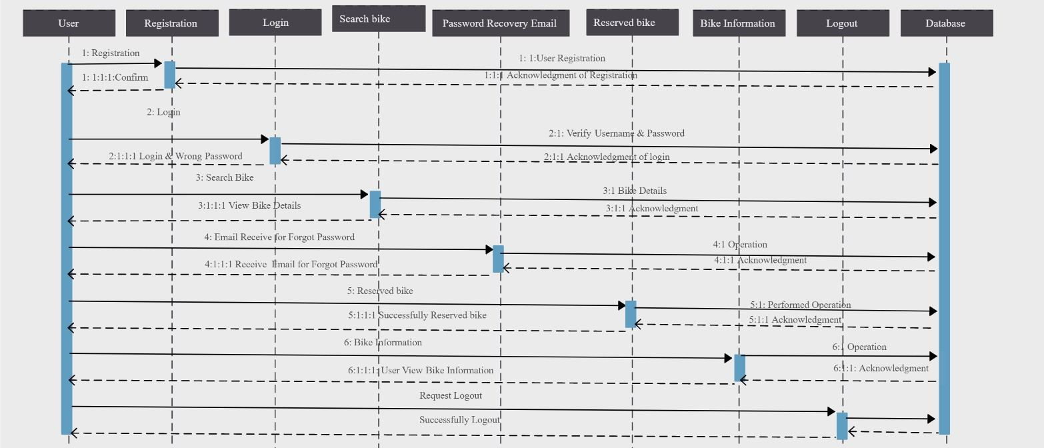

## Website Map Diagram:



**ONLINE BIKE RENTAL**

HOME

ABOUT

LOGIN

SIGNUP

ADMIN

ADMIN

USER

USER

**HOME PAGE:-**

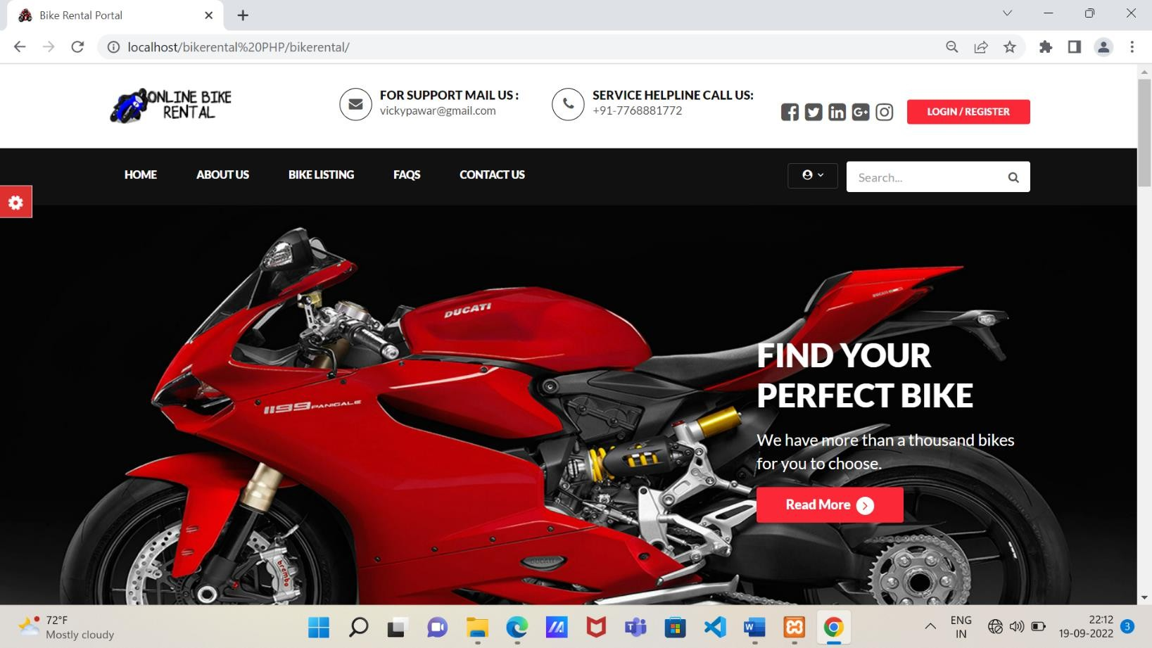

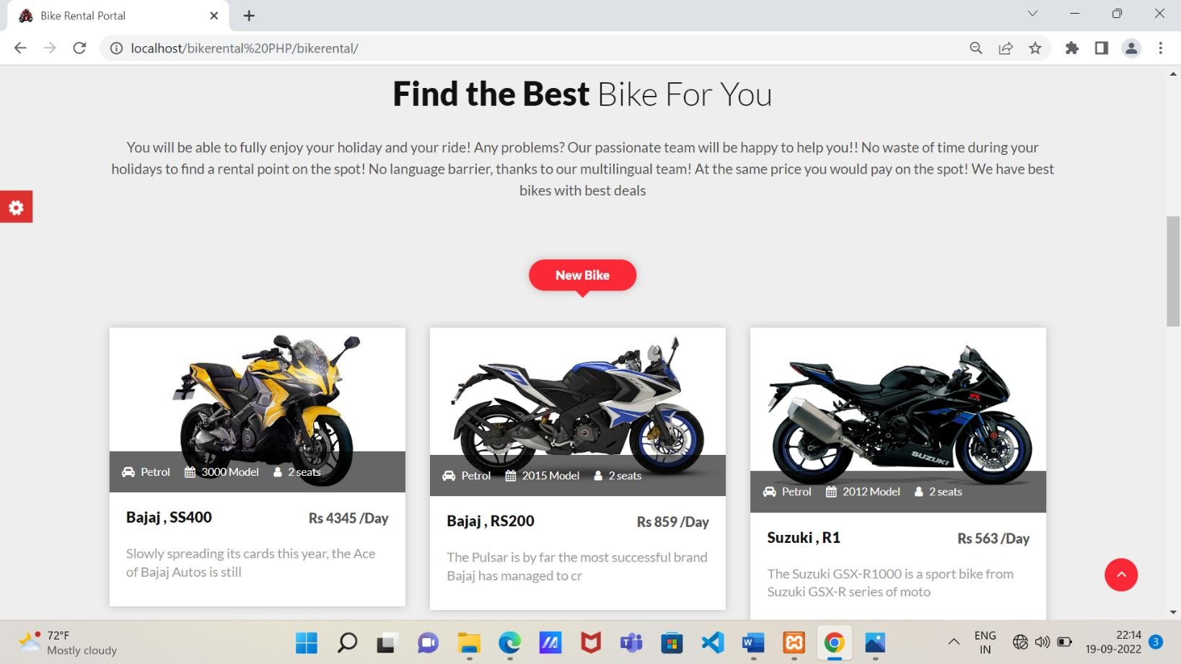

## LOGIN SCREEN:-

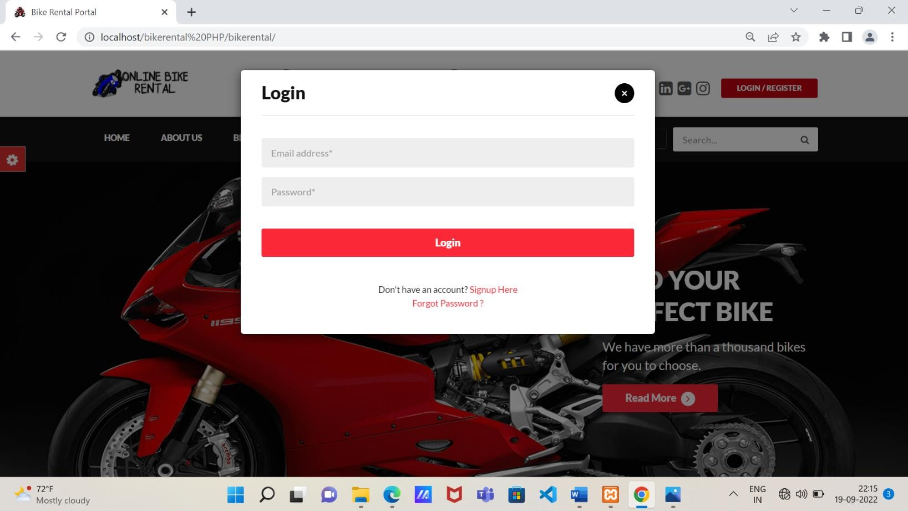

**REGISTRATION:-**

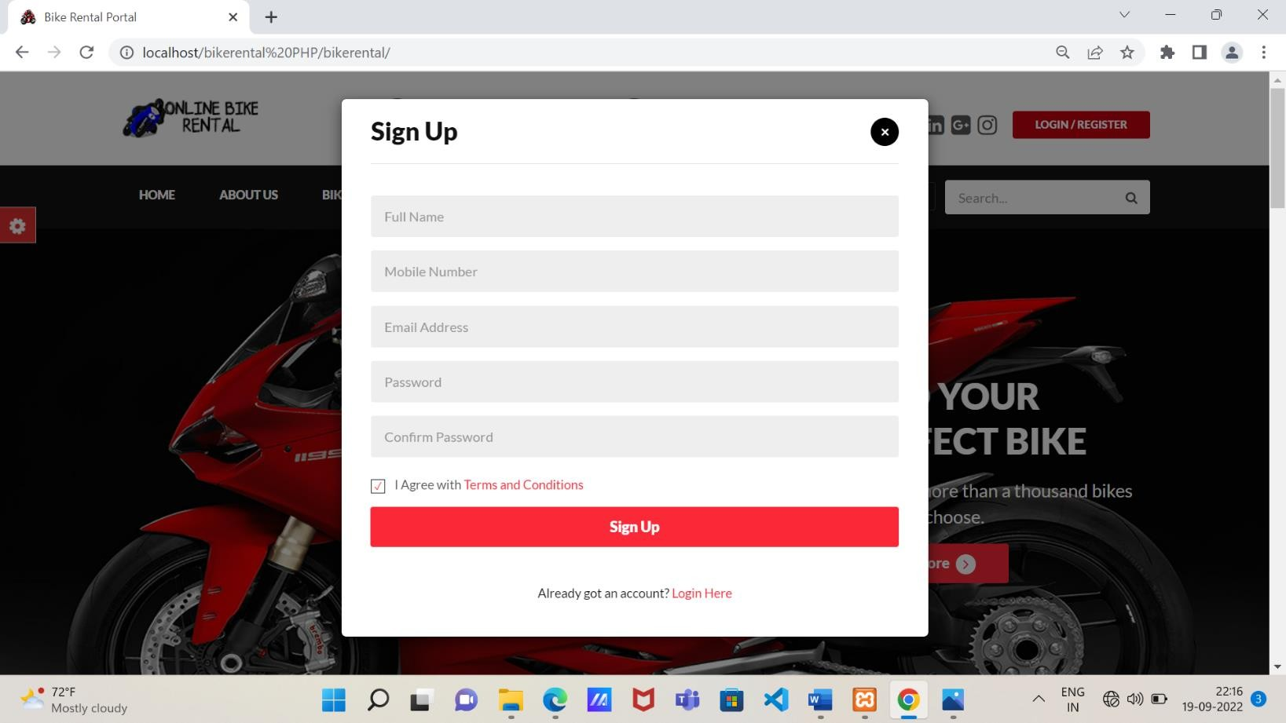

## ADMIN:-

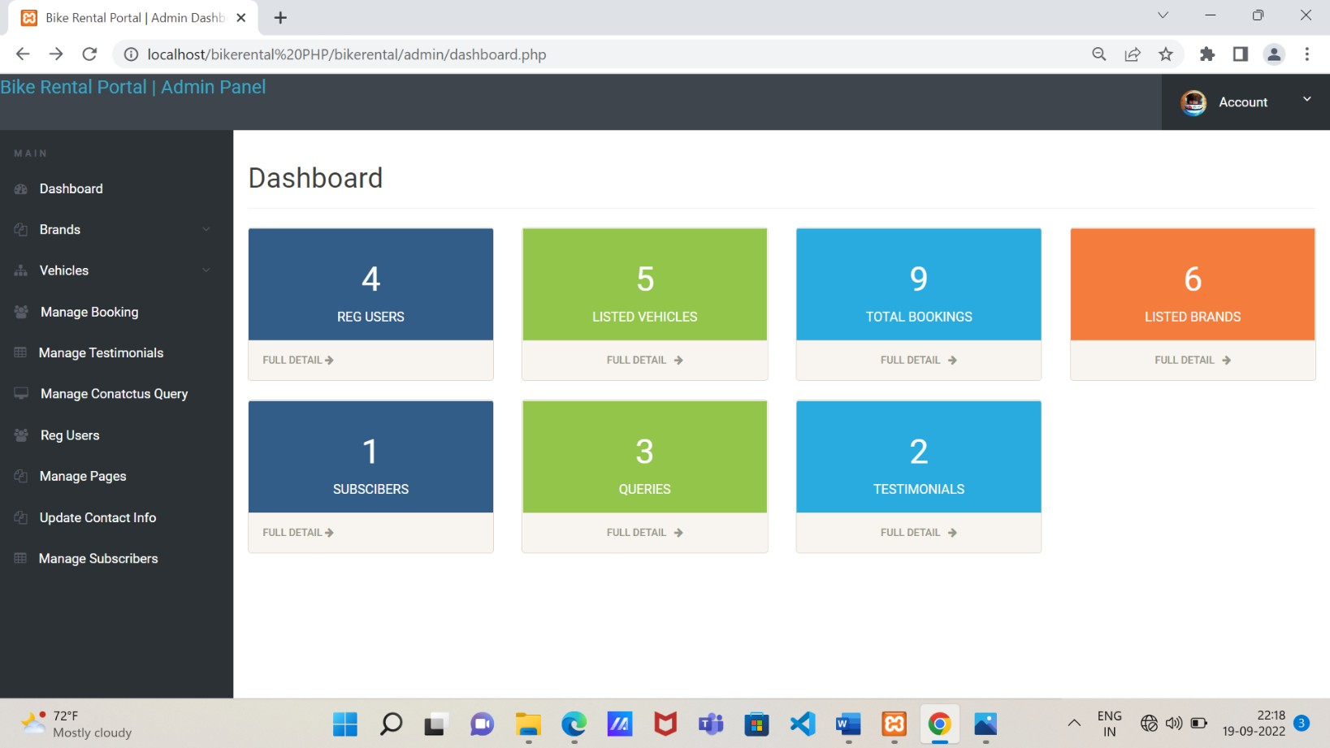

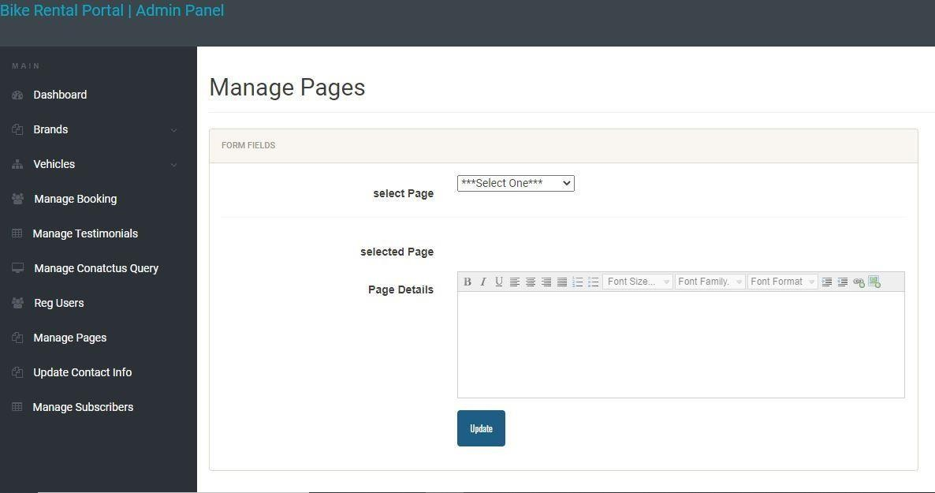

**ABOUT US:-**

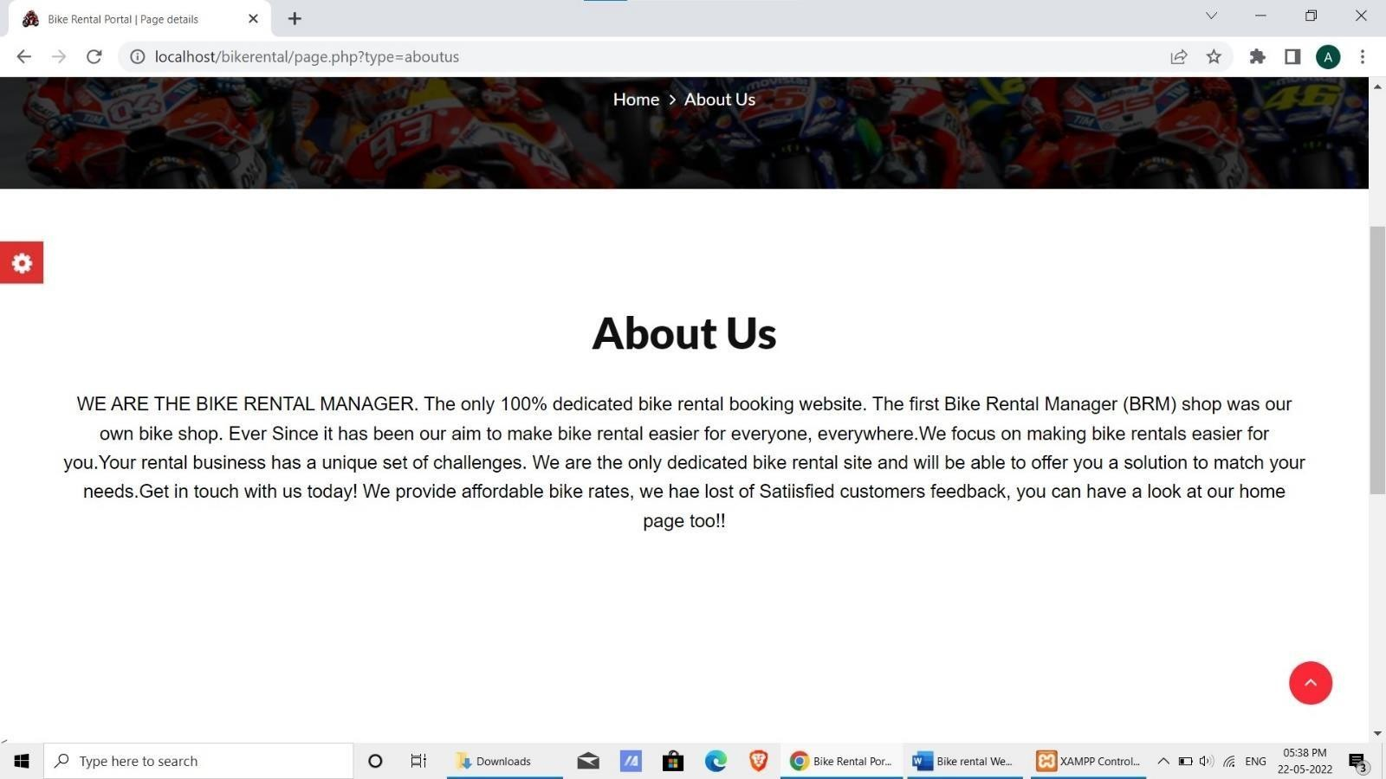

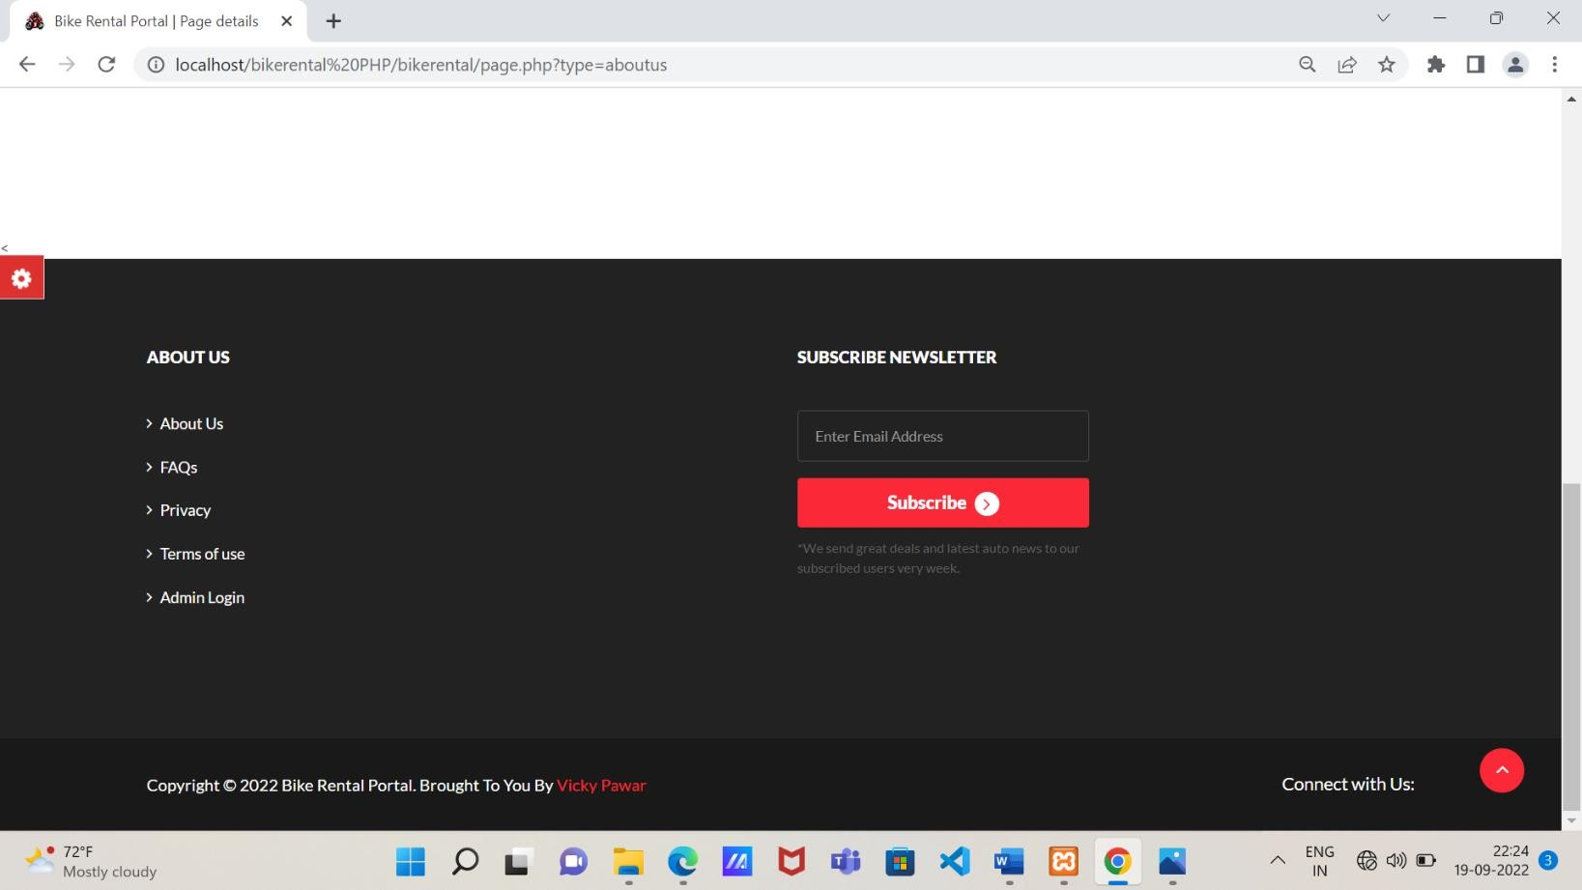

## Description of Tables:-

**ADMIN:-**



**USER:-**

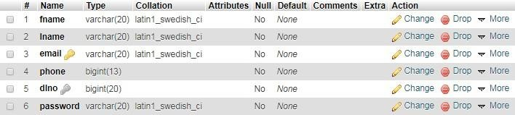

**BIKE:-**

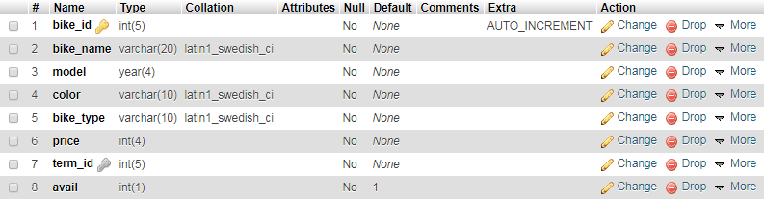

**PAYMENT:-**

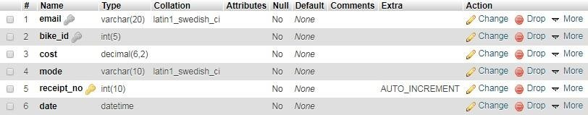

## FUTURE ENHANCEMENT:-

Once the final Bike Rental System is built, business students will become involved with an economic and marketing analysis. The engineering programs will pay for the construction of the bike system from funds budgeted for the capstone class. An initial thought is for local business to sponsor each of the bikes. As an incentive, they will be allowed to put an advertisement for their business on the bike they sponsor. Asmall monthly fee will then be charged to continue the sponsorship. The fees collected will be used to contract with a local bike shop to maintain the condition bikes. The implementation of the final bike rental system is truly the final step in maintaining the community relations link.

Further Enhancement can also be done by providing access permissions to the employees, Try to Implement the GPS System in Bikes.

To maximize the use of Bike Renting System, the lead agency needs to have the support of stakeholders and partners. These stakeholders may be including Local municipality (funding and space), Public transit operators, User association and other groups (e.g. vehicle sharing companies).

## BIBLIOGRAPHY:-

* + 1. Object Oriented Databases and their applications.
    2. Software Engineering.
    3. PHP & MYSQL Web Development.

## WEBSITES :-

1. [www.wikipedia.com](http://www.wikipedia.com/)
2. [www.phppoint.com](http://www.phppoint.com/)
3. [www.slideshare.com](http://www.slideshare.com/)
4. [www.w3school.com](http://www.w3school.com/)